**NOTRE DAME UNIVERSITY BANGLADESH**



LAB Assignment 2

Object Oriented Programming

Submitted to: Mondira Chakraborty (Lecturer NDUB)

Submitted by: Shazidul Alam

Subject: OOP

Student ID: 0692220005101009

Batch: CSE-19

**Question---------------------------------------------------------------------Page**

**1. Write a code that inputs one number consisting of five digits from the user, separates the number into its individual digits and prints the digits separated from one another by three spaces each. For example, if the user types in the number 23459, the program should print 2 3 4 5 9.-----------------------------------------------------------------01**

**2. Create a class called “CheckMethodOverload” that includes two double instances, two float instances, two int instance and two long instance and four methods named max having the following numbers of parameters and types.**

**i. One with two double parameters.**

**ii. One with two float parameters.**

**iii. One with two int parameters.**

**iv. One with two long parameters.----------------------------------------02**

**3. An integer number is said to be a perfect number if its factors, including 1 (but not the number itself), sum to the number. For example, 6 is a perfect number, because 6 = 1 + 2 + 3. Write a method “isPerfect” that determines whether parameter number is a perfect number. Use this method in an application that displays all the perfect numbers between 1 and 1000. Display the factors of each perfect number to confirm that the number is indeed perfect. Challenge the computing power of your computer by testing numbers much larger than 1000. Display the results.-----------------03**

**4. A positive integer is prime if it’s divisible by only 1 and itself. For example, 2, 3, 5 and 7 are prime, but 4, 6, 8 and 9 are not. The number 1, by definition, is not prime.**

**a. Write a method that determines whether a number is prime.**

**b. Use this method in an application that determines and displays all the prime numbers less than 10,000. How many numbers up to 10,000 do you have to test to ensure that you’ve found all the primes?**

**c. Initially, you might think that n/2 is the upper limit for which you**

**must test to see whether a number n is prime, but you need only go as high as the square root of n. Rewrite the program and run it both ways.-----------------------------------------------------------------------------04**

**5. Create a class named “Student” with variables like name, roll no, school name, college name and methods/constructors to set the variables, print the variables and update the roll no. for at least 3 students (object). -------------------------------------------------------------05**

**6. Create a class named “Plant” with variables like name, size, type, primary color, weather, season, price etc. and methods/constructors to set the variables, print the variables and update the variables for Orange, Tomato and Pine tree (object). ---------------------------------08**

**7. Create a class named “Shape” with variables like name, height, width, length etc., constructor to set the variables and methods to print the variables and update the variables for Triangle, Rectangle, Square (object). ------------------------------------------------11**

**8. Create two classes named “Rectangle” and “Triangle” with variables like name, height, width, length etc., constructors to set the variables and methods to print the variables and methods to fins area and perimeter for objects like Rectangle1, Rectangle1 of Rectangle class and Triangle1, Triangle2 of Triangle class.---------14**

**9. Create a class named “Vehicle” with variables like name, color, position (x,y) etc., constructor to set the variables and methods to print the variables, update the position, find the speed of the vehicles and update the speed. --------------------------------------------17**

**10.Create a class called Employee that includes three instance variables—a first name, a last name and a monthly salary. Provide a constructor that initializes the three instance variables. Provide a set and a get method for each instance variable. If the monthly salary is not positive, do not set its value. Rename the file as Employee Test that demonstrates class Employee’s capabilities. Create two Employee objects and display each object’s yearly salary. Then give each Employee a 10% raise and display each Employee’s yearly salary again.-------------------------------------------19**

**1) Write a code that inputs one number consisting of five digits from the user, separates the number into its individual digits and prints the digits separated from one another by three spaces each. For example, if the user types in the number 23459, the program should print 2 3 4 5 9.**

package shazid.part1;

import java.util.Scanner;

public class Part1 {

public static void main(String[] args) {

Scanner input = new Scanner(System.in);

System.out.print("Enter a five-digit number: ");

int number = input.nextInt();

int digit1 = number / 10000;

int digit2 = (number % 10000) / 1000;

int digit3 = (number % 1000) / 100;

int digit4 = (number % 100) / 10;

int digit5 = number % 10;

System.out.println(digit1 + " " + digit2 + " " + digit3 + " " + digit4 + " " + digit5); }}

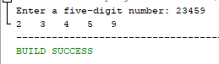

**01**

**2. Create a class called “CheckMethodOverload” that includes two double instances, two float instances, two int instance and two long instance and four methods named max having the following numbers of parameters and types. i. One with two double parameters. ii. One with two float parameters. iii. One with two int parameters. iv. One with two long parameters.**

public class Part2 {

double d1, d2;

float f1, f2;

int i1, i2;

long l1, l2;

public Part2(double d1, double d2, float f1, float f2, int i1, int i2, long l1, long l2) {

d1 = d1;

d2 = d2;

f1 = f1;

f2 = f2;

i1 = i1;

i2 = i2;

l1 = l1;

l2 = l2;

}

public double max(double a, double b) {

return (a > b) ? a : b;

}

public float max(float a, float b) {

return (a > b) ? a : b;

}

public int max(int a, int b) {

return (a > b) ? a : b;

}

public long max(long a, long b) {

return (a > b) ? a : b;

}

public static void main(String[] args) {

Part2 obj = new Part2(1.0, 2.0, 3.0f, 4.0f, 5, 6, 7L, 8L);

System.out.println("Max of two doubles: " + obj.max(3.0, 4.0));

System.out.println("Max of two floats: " + obj.max(5.0f, 6.0f));

System.out.println("Max of two ints: " + obj.max(7, 8));

System.out.println("Max of two longs: " + obj.max(9L, 10L)); }}

**02**

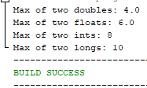

**3. An integer number is said to be a perfect number if its factors, including 1 (but not the number itself), sum to the number. For example, 6 is a perfect number, because 6 = 1 + 2 + 3. Write a method “isPerfect” that determines whether parameter number is a perfect number. Use this method in an application that displays all the perfect numbers between 1 and 1000. Display the factors of each perfect number to confirm that the number is indeed perfect. Challenge the computing power of your computer by testing numbers much larger than 1000. Display the results.**

package shazid.part3;

public class Part3 {

public static boolean isPerfect(int num){

int sum = 0;

for (int i = 1; i < num; i++) {

if (num % i == 0) {

sum += i;}}

return sum == num; }

public static void main(String[] args) {

for (int i = 1; i <= 1000; i++) {

if (isPerfect(i)) {

System.out.print(i + " = 1");

for (int j = 2; j < i; j++) {

if (i % j == 0) {

System.out.print(" + " + j);}}

System.out.println();}}}}

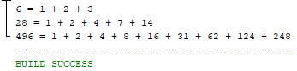

**03**

**4. A positive integer is prime if it’s divisible by only 1 and itself. For example, 2, 3, 5 and 7 are prime, but 4, 6, 8 and 9 are not. The number 1, by definition, is not prime.**

**a. Write a method that determines whether a number is prime.**

**b. Use this method in an application that determines and displays all the prime numbers less than 10,000. How many numbers up to 10,000 do you have to test to ensure that you’ve found all the primes?**

**c. Initially, you might think that n/2 is the upper limit for which you must test to see whether a number n is prime, but you need only go as high as the square root of n. Rewrite the program and run it both ways.**

package shazid.part4;

public class Part4 {

public static boolean isPrime(int num) {

if (num < 2) {

return false; }

for (int i = 2; i <= Math.sqrt(num); i++) {

if (num % i == 0) {

return false;}}

return true; }

public static void main(String[] args) {

int count = 0;

for (int i = 2; i < 10000; i++) {

if (isPrime(i)) {

System.out.println(i);

count++; }}

System.out.println("Total prime numbers found: " + count);

System.out.println("Total numbers tested: " + (10000 - 2));}}

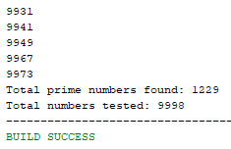

**04**

**5. Create a class named “Student” with variables like name, roll no, school name, college name and methods/constructors to set the variables, print the variables and update the roll no. for at least 3 students (object).**

package shazid.part5;

import java.util.*;

class Student{

String name;

int rollNo;

String schoolName;

String collegeName;

public Student(String Name, int RollNo, String SchoolName, String CollegeName) {

name = Name;

rollNo = RollNo;

schoolName = SchoolName;

collegeName = CollegeName; }

public void printInfo() {

System.out.println("Name: " + name);

System.out.println("Roll No: " + rollNo);

System.out.println("School Name: " + schoolName);

System.out.println("College Name: " + collegeName); }

public void updateRollNo(int newRollNo) {

rollNo = newRollNo; }}

public class Part5 {

public static void main(String[] args){

Scanner input = new Scanner(System.in);

// Get details for the first student

System.out.println("Enter details for Student 1:");

System.out.print("Enter name: ");

String name1 = input.nextLine();

System.out.print("Enter roll number: ");

int roll1 = input.nextInt();

input.nextLine();

System.out.print("Enter school name: ");

String school1 = input.nextLine();

System.out.print("Enter college name: ");

String college1 = input.nextLine();

Student student1 = new Student(name1, roll1, school1, college1);

// Get details for the second student

**05**

System.out.println("\nEnter details for Student 2:");

System.out.print("Enter name: ");

String name2 = input.nextLine();

System.out.print("Enter roll number: ");

int roll2 = input.nextInt();

input.nextLine();

System.out.print("Enter school name: ");

String school2 = input.nextLine();

System.out.print("Enter college name: ");

String college2 = input.nextLine();

Student student2 = new Student(name2, roll2, school2, college2);

// Get details for the third student

System.out.println("\nEnter details for Student 3:");

System.out.print("Enter name: ");

String name3 = input.nextLine();

System.out.print("Enter roll number: ");

int roll3 = input.nextInt();

input.nextLine();

System.out.print("Enter school name: ");

String school3 = input.nextLine();

System.out.print("Enter college name: ");

String college3 = input.nextLine();

Student student3 = new Student(name3, roll3, school3, college3);

// Print the details for all three students

System.out.println("\nDetails of Student 1:");

student1.printInfo();

System.out.println("\nDetails of Student 2:");

student2.printInfo();

System.out.println("\nDetails of Student 3:");

student3.printInfo(); }}

**06**

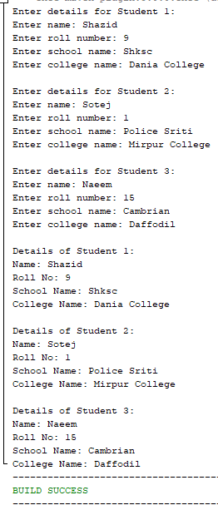

**07**

**6. Create a class named “Plant” with variables like name, size, type, primary color, weather, season, price etc. and methods/constructors to set the variables, print the variables and update the variables for Orange, Tomato and Pine tree (object).**

package shazid.part6;

import java.util.*;

class Plant {

String name;

double size;

String type;

String primaryColor;

String weather;

String season;

double price;

Plant(String plantname, double plantsize, String planttype, String primaryclr, String weathertype, String plantseason, double plantprice) {

name = plantname;

size = plantsize;

type = planttype;

primaryColor = primaryclr;

weather = weathertype;

season = plantseason;

price = plantprice; }

public void printPlant() {

System.out.println("Name: " + name);

System.out.println("Size: " + size);

System.out.println("Type: " + type);

System.out.println("Primary Color: " + primaryColor);

System.out.println("Weather: " + weather);

System.out.println("Season: " + season);

System.out.println("Price: " + price); }

public void updatePlant(String n, double s, String t, String pColor, String wr, String sn, double pr) {

**08**

name = n;

size = s;

type = t;

primaryColor = pColor;

weather = wr;

season = sn;

price = pr; }}

public class Part6 {

public static void main(String[] args) {

Scanner sc = new Scanner(System.in);

System.out.print("Enter the price of orange:");

double value1 = sc.nextDouble();

System.out.print("Enter the price of tomato:");

double value2 = sc.nextDouble();

System.out.print("Enter the price of pine tree:");

double value3 = sc.nextDouble();

Plant orange = new Plant("Orange", 4.5, "Fruit", "Orange", "Sunny", "Summer", value1);

Plant tomato = new Plant("Tomato", 2.5, "Vegetable", "Red", "Sunny", "Summer", value2);

Plant pineTree = new Plant("Pine Tree", 60.0, "Tree", "Green", "Cold", "Winter", value3);

System.out.println("Before Update:");

orange.printPlant();

tomato.printPlant();

pineTree.printPlant();

orange.updatePlant("Sweet Orange", 5.5, "Fruit", "Orange", "Sunny", "Summer",value1);

tomato.updatePlant("Cherry Tomato", 1.5, "Vegetable", "Red", "Sunny", "Summer", value2);

pineTree.updatePlant("Christmas Tree", 72.0, "Tree", "Green", "Cold", "Winter", value3);

System.out.println("\nAfter Update:");

orange.printPlant();

tomato.printPlant();

pineTree.printPlant(); }}

**09**

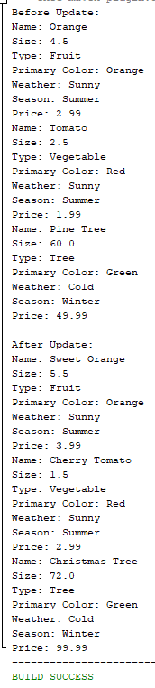

**10**

**7. Create a class named “Shape” with variables like name, height, width, length etc., constructor to set the variables and methods to print the variables and update the variables for Triangle, Rectangle, Square (object).**

package shazid.part7;

public class Part7 {

public static void main(String[] args) {

Triangle triangle = new Triangle("Triangle", 5, 10);

Rectangle rectangle = new Rectangle("Rectangle", 8, 12);

Square square = new Square("Square", 6);

// Print initial values of variables

System.out.println("Initial values:");

triangle.printInfo();

rectangle.printInfo();

square.printInfo();

// Update variables

triangle.updateHeight(7);

rectangle.updateWidth(15);

square.updateSide(9);

// Print updated values of variables

System.out.println("\nUpdated values:");

triangle.printInfo();

rectangle.printInfo();

square.printInfo(); }}

class Shape {

String name;

double height;

double width;

double length;

public Shape(String n, double h, double w, double l) {

name = n;

height = h;

width = w;

length = l; }

public void printInfo() {

System.out.println("Name: " + name);

System.out.println("Height: " + height);

System.out.println("Width: " + width);

System.out.println("Length: " + length); }}

**11**

class Triangle extends Shape {

public Triangle(String name, double height, double width) {

super(name, height, width, 0); }

public void updateHeight(double newHeight) {

height = newHeight; }

public void updateWidth(double newWidth) {

width = newWidth; }}

class Rectangle extends Shape {

public Rectangle(String name, double height, double width) {

super(name, height, width, 0); }

public void updateHeight(double newHeight) {

height = newHeight; }

public void updateWidth(double newWidth) {

width = newWidth; }}

class Square extends Shape {

public Square(String name, double side) {

super(name, side, side, 0); }

public void updateSide(double newSide) {

height = newSide;

width = newSide; }}

**12**

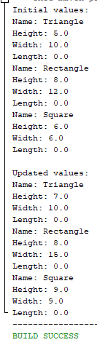

**13**

**8. Create two classes named “Rectangle” and “Triangle” with variables like name, height, width, length etc., constructors to set the variables and methods to print the variables and methods to fins area and perimeter for objects like Rectangle1, Rectangle1 of Rectangle class and Triangle1, Triangle2 of Triangle class.**

package shazid.part8;

class Shape {

String name;

double height;

double width;

double length;

public Shape(String name, double height, double width, double length) {

this.name = name;

this.height = height;

this.width = width;

this.length = length; }

public void printInfo() {

System.out.println("Name: " + name);

System.out.println("Height: " + height);

System.out.println("Width: " + width);

System.out.println("Length: " + length); }

public void updateDimensions(double height, double width, double length) {

this.height = height;

this.width = width;

this.length = length; }}

class Rectangle extends Shape {

public Rectangle(String name, double height, double width, double length) {

super(name, height, width, length); }

public double getArea() {

return height * width; }

public double getPerimeter() {

return 2 * (height + width); }}

class Triangle extends Shape {

public Triangle(String name, double height, double width, double length) {

super(name, height, width, length); }

**14**

public double getArea() {

return 0.5 * height * width; }

public double getPerimeter() {

return height + width + length; }}

public class Part8 {

public static void main(String[] args) {

Rectangle rectangle1 = new Rectangle("Rectangle1", 4, 6, 0);

Rectangle rectangle2 = new Rectangle("Rectangle2", 3, 5, 0);

Triangle triangle1 = new Triangle("Triangle1", 5, 7, 8);

Triangle triangle2 = new Triangle("Triangle2", 6, 9, 10);

// Print the initial dimensions and area/perimeter of each shape

System.out.println("Initial Dimensions:");

rectangle1.printInfo();

System.out.println("Area: " + rectangle1.getArea());

System.out.println("Perimeter: " + rectangle1.getPerimeter() + "\n");

rectangle2.printInfo();

System.out.println("Area: " + rectangle2.getArea());

System.out.println("Perimeter: " + rectangle2.getPerimeter() + "\n");

triangle1.printInfo();

System.out.println("Area: " + triangle1.getArea());

System.out.println("Perimeter: " + triangle1.getPerimeter() + "\n");

triangle2.printInfo();

System.out.println("Area: " + triangle2.getArea());

System.out.println("Perimeter: " + triangle2.getPerimeter() + "\n");

// Update the dimensions of Rectangle1 and Triangle2

rectangle1.updateDimensions(5, 8, 0);

triangle2.updateDimensions(8, 12, 15);

// Print the updated dimensions and area/perimeter of each shape

System.out.println("Updated Dimensions:");

rectangle1.printInfo();

System.out.println("Area: " + rectangle1.getArea());

System.out.println("Perimeter: " + rectangle1.getPerimeter() + "\n");

triangle2.printInfo();

System.out.println("Area: " + triangle2.getArea());

System.out.println("Perimeter: " + triangle2.getPerimeter() + "\n"); }}

**15**

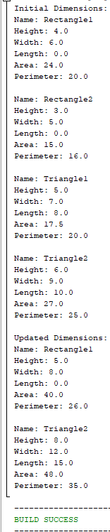

**16**

**9. Create a class named “Vehicle” with variables like name, color, position (x,y) etc., constructor to set the variables and methods to print the variables, update the position, find the speed of the vehicles and update the speed.**

package shazid.part9;

class Vehicle {

String name;

String color;

double xPosition;

double yPosition;

double speed;

public Vehicle(String n, String c, double xPos, double yPos, double spd) {

name = n;

color = c;

xPosition = xPos;

yPosition = yPos;

speed = spd; }

public void printInfo() {

System.out.println("Name: " + name);

System.out.println("Color: " + color);

System.out.println("Position: (" + xPosition + ", " + yPosition + ")");

System.out.println("Speed: " + speed + " mph"); }

public void updatePosition(double newX, double newY) {

xPosition = newX;

yPosition = newY; }

public double findSpeed() {

return speed; }

public void updateSpeed(double newSpeed) {

speed = newSpeed; }}

public class Part9 {

public static void main(String[] args) {

// create a vehicle object

Vehicle car = new Vehicle("Car", "Red", 0, 0, 60);

// print the initial information

System.out.println("Initial Information:");

car.printInfo();

// update the position of the vehicle

car.updatePosition(10, 20);

**17**

// print the updated information

System.out.println("\nUpdated Information:");

car.printInfo();

// find the speed of the vehicle

double speed = car.findSpeed();

System.out.println("\nSpeed: " + speed + " mph");

// update the speed of the vehicle

car.updateSpeed(80);

// print the updated information

System.out.println("\nUpdated Information:");

car.printInfo(); }}

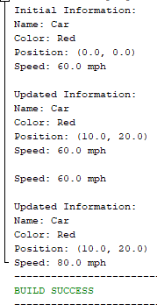

**18**

**10. Create a class called Employee that includes three instance variables—a first name, a last name and a monthly salary. Provide a constructor that initializes the three instance variables. Provide a set and a get method for each instance variable. If the monthly salary is not positive, do not set its value. Rename the file as Employee Test that demonstrates class Employee’s capabilities. Create two Employee objects and display each object’s yearly salary. Then give each Employee a 10% raise and display each Employee’s yearly salary**

**again.**

package shazid.part10;

class Employee {

String firstName;

String lastName;

double monthlySalary;

public Employee(String fName, String lName, double monthlyS) {

firstName = fName;

lastName = lName;

if (monthlyS > 0) {

this.monthlySalary = monthlyS; }}

public String getFirstName() {

return firstName;}

public void setFirstName(String fName) {

firstName = fName;}

public String getLastName() {

return lastName; }

public void setLastName(String lName) {

lastName = lName; }

public double getMonthlySalary() {

return monthlySalary; }

public void setMonthlySalary(double monthlyS) {

if (monthlyS > 0) {

monthlySalary = monthlyS; }}

public double getYearlySalary() {

return monthlySalary * 12; }

**19**

public double getRaiseAmount() {

return monthlySalary * 0.1; }

public void applyRaise() {

monthlySalary += getRaiseAmount(); }}

public class Part10 {

public static void main(String[] args) {

Employee employee1 = new Employee("Naeem", "Uddin", 5000);

Employee employee2 = new Employee("Shazidul", "Alam", 6000);

System.out.println("Yearly salary for " + employee1.getFirstName() + " " + employee1.getLastName() +

" is " + employee1.getYearlySalary());

System.out.println("Yearly salary for " + employee2.getFirstName() + " " + employee2.getLastName() +

" is " + employee2.getYearlySalary());

employee1.applyRaise();

employee2.applyRaise();

System.out.println("After 10% raise, yearly salary for " + employee1.getFirstName() + " " + employee1.getLastName() +

" is " + employee1.getYearlySalary());

System.out.println("After 10% raise, yearly salary for " + employee2.getFirstName() + " " + employee2.getLastName() +

" is " + employee2.getYearlySalary()); }}

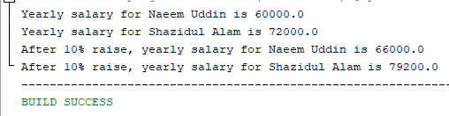

**20**

The end